**Student Activity Guide: Creating a Personal Favicon** Name: _______________________

Unit 1 Lesson 11

**Scenario**

A favicon is a small image, usually 16x16 pixels, that is typically shown in a web browser’s address bar next to the web address for a particular website or web page. It is typically a small version of a company logo or some other symbol for the site. Favicons are designed by artists and programmed into web pages by web designers. Below are some examples of favicons -- you might recognize some!

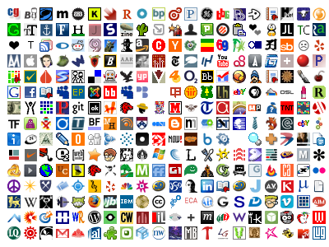

source:[*http://www.searchprosystems.com/google-releases-favicons-to-their-internet-marketing-text-ads*](http://www.searchprosystems.com/google-releases-favicons-to-their-internet-marketing-text-ads)

**Directions**

Create a personal 16x16 favicon and encode it using the Pixelation tool v.3. The image should represent your personality in some distinctive way. You will be using this favicon in future lessons so be creative and thoughtful. When you have finished your favicon, share it with others in the class.

Summarize your learning by creating step-by-step instructions to recreate your favicon. Write the instructions as if you were writing a technical mini-manual for someone new to image encoding. Be sure to explain the color selection and encoding in very precise computer science language. Turn in your mini-manual.

**Requirements**:

* The icon must be 16x16 pixels.
* You must use the Pixelation tool to encode the bits of color information.
* The image must be encoded with at least 3 bits per pixel.

**Things to think about:**

* The more colors you want, the more bits-per-pixel you will have to use. If there are very specific colors you need, you might need to increase the number of bits to be able to display them.
* A simple design with a few basic colors is probably the best solution.
* Plan ahead: Sketch your design before starting to encode the bits. You might want to use a tool to help you draw small images. Suggestions:
  + [*http://favicon-generator.org/editor/*](http://favicon-generator.org/editor/)
  + [*http://makepixelart.com/free/*](http://makepixelart.com/free/)
* Consider switching the Pixelation tool into HEX mode instead of binary. This will enable you to more easily use a greater number of bits. If you use hex you should consider using 12-bits-per-pixel (4096 colors!) because that maps to exactly 3 hex digits, which also maps easily to RGB - 1 hex digit for each. For example, the color red: 1111 0000 0000 in hex is F00. To make a darker red, just choose a smaller hex digit for the red value, such as A00.